**ASSIGNMENT 2 FRONT SHEET**

|  |  |  |  |
| --- | --- | --- | --- |
| **Qualification** | **BTEC Level 5 HND Diploma in Computing** | | |
| **Unit number and title** | Unit 13:Computing Research Project | | |
| **Submission date** |  | **Date Received 1st submission** |  |
| **Re-submission Date** |  | **Date Received 2nd submission** |  |
| **Student Name** | Nguyễn Trọng Duy | **Student ID** | GCD17313 |
| **Class** | GCD0901 | **Assessor name** | Phyo Min Tun |
| **Student declaration**  I certify that the assignment submission is entirely my own work and I fully understand the consequences of plagiarism. I understand that making a false declaration is a form of malpractice. | | | |
|  |  | **Student’s signature** | Duy |

**Grading grid**

|  |  |  |  |
| --- | --- | --- | --- |
| P6 | P7 | M4 | D3 |
|  |  |  |  |

|  |  |  |  |  |
| --- | --- | --- | --- | --- |
| **❒ Summative Feedback: ❒ Resubmission Feedback:** | | | | |
| **Grade:** | | **Assessor Signature:** | **Date:** | |
| **Internal Verifier’s Comments:** | | | | |
| **Signature & Date:** | | | | |
| **Assignment Brief and Guidance:** | | |
| **Scenario**  As you have completed your research project now it is time to look back and learn some lessons from your work. You need to prepare a report to describe your personal development. **Remember to write your own experience, thoughts and it is specific to YOU NOT explaining the general concepts**.  Here are some suggestions which you can put in the report:   * Project’s proposal, the research process(sequential example) how it helped you completed your research * Reflection on the merits, limitations and potential pitfalls of the chosen methods: examples qualitative research, secondary research; the relationship between the two in your research * The roles of Literature **review in your** project * How did you create project plan and how often you did you update it. Why you need you need to update the plan * How often did you meet the tutor and how the tutor helped you to create more effective research. * How did you choose participations(sample types, sizes) and the importance of it? * How did you present your research result? * **Consider other research approach** and improvements in future research * ….. | | |

|  |  |  |
| --- | --- | --- |
| Learning Outcomes and Assessment Criteria | | |
| Pass | Merit | Distinction |
| **LO4** Reflect on the application of research methodologies and concepts | | **D3** Demonstrate reflection and engagement in the resource process  leading to recommended actions  for future improvement. |
| **P6** Reflect on the effectiveness of research methods applied for meeting objectives of the computing research project.  **P7** Consider alternative research methodologies and lessons learnt in view of the outcomes. | **M4** Provide critical reflection and insight that results in recommended  Actions for improvements and future research considerations. |

Contents

I. Introduction 6

II. SUMMARY FIRST HALF OF THE RESEARCH 6

III. PROJECT PERPOSAL 6

Authorization 6

Research Process 7

Reflect on the advantages and limitations of research methods. 9

Figure 4 : Research Ethics Approval Form 9

IV. REFLECTION ON THE RESEACH PROCESSES 9

Primary Research. 9

Advantages of Primary research 9

Disadvantages of primary research 10

-How our project will use document reviews 10

Perceived Usefulness (PU) 10

Service quality. (SVQ) 10

Satisfaction (ST) 10

Trust (TR) 11

This factor is critical for any undertaking in the world. To achieve this properly, Lazada must protect the user's personal information. Secure and give users with the essential security functions. Also included are details such as bank accounts and security services. The obtained data will be used to assess the customer's trust in the product and provide feedback for Lazada to update and change. 11

Step 1: Identify all stakeholders 11

Step 2: Define roles and duties in step two. 11

Step 3: Hold a kick-off meeting in step three. 11

Step 4: Define project scope, budget, and schedule. 11

Step 5: Set and order your goals in step five. 11

Step 6 Determine distribution products in 11

Step 7: Collecting data 12

Step 9: Disseminate the project schedule 12

-Why should the Project Plan be updated? 12

Secondary Research. 13

Qualitative Research. 13

Quantitative research 14

Advantages of Quantitative Research 14

Disadvantages of Quantitative Research 14

The roles of my tutor 14

-Participation (sample type, size) and its importance 15

-THE IMPORTANCE OF CHOOSING PARTICIPATIONS: 15

COMPARING MEANS 15

Figure 1 TR1 * Age 16

Figure 2 TR1 * Gender 16

Figure 3 TR1 * Occupation 16

Figure 4 TR1 * Education 16

Figure 5 TR1 * Daily Hour 17

Figure 6 TR2 * Gender 17

Figure 7 TR2 * Age 17

Figure 8 TR2 * Education 18

Figure 9 TR2 * Daily Hours 18

Figure 10 TR2 * Occupation 18

Figure 11 TR3 * Gender and Age 19

Figure 12 TR3 * Education and Occupation 19

Figure 13 TR3 * Daily Hours 20

Figure 14 One Sample T Test Table 21

Figure 15 Correlations Table 22

V. RECOMMENDED ACTIONS FOR IMPROVEMENTS AND FUTURE RESEARCH CONSIDERATIONS 24

LIMITATION AND IMPROVEMENTS IN FUTURE RESEARCH 24

VI. CONCLUSION: 24

Bibliography 24

# I. Introduction

# II. SUMMARY FIRST HALF OF THE RESEARCH

# III. PROJECT PERPOSAL

## Authorization

Based on the research in each part, I met with my teacher to seek comments on how to make my study more comprehensive. Furthermore, the use of technology and some important material on the internet has really aided me in improving my research.

|  |
| --- |
| • Research proposal form |
| **Student Name:** Nguyen Trong Duy  **Student Number:** GCD17313  **Tutor:** Phyo Min Tun **Date:** 28/6/2022  **Unit 13:** Computing research project |
| **Propose title:** Use Lazada platform in shopping online |
| • Research question and objectives |
| * **Research questions:**   What factors can affect the use of Lazada by Vietnamese users?  Does the use of Lazada negatively or positively affect Vietnamese users?  What role does Lazada play in the lives of Vietnamese people?   * **Research Objective:**   The primary goal of this research paper is to assist businesses in determining the factors influencing the use of the Lazada platform for online shopping and exploiting the behavioral intent of the Lazada platform's primary audience. in Vietnam to develop a viable business strategy |

## Research Process

* Identifying the Problems  
  A well-defined problem guides the researcher through all of the critical stages of the research process, from goal definition to research method selection. To do a survey research, we must first define the research topic and objectives, then research methods, research questions, and so on. implementation of an issue We shall investigate the use of the Lazada application in this study.
* Reviewing of Literature

The review of relevant literature is critical to the research process. It allows the researcher to frame his problem in terms of specific, as-yet untapped aspects of a vast field of interest. This type of test exposes us to a broader range of knowledge and gives us with the advanced knowledge we need to follow the research process efficiently.

By completing an appropriate evaluation of the available literature, a researcher can generate consistency between his study findings and those of others.

Even for inexperienced researchers, reviewing previous research on comparable or related phenomena is critical. If researchers overlook the body of current literature, they may waste time and effort.

* Research goals, questions, and hypotheses   
    
  The researcher should use lazada to define the problem as it relates to the study purpose after identifying and defining the research topic.

The purpose should clearly express the topic area to be researched, specify the type of data to be collected, and define the scope of the study. A well-crafted, testable research hypothesis is the best approach to express a study objective.

A hypothesis is an unproven claim or assertion that can be proven true or wrong by empirical data. Hypothetical arguments propose a possible answer to a research topic.

* Choosing the Study Design

A research design is utilized as a guide or framework to fulfill the goals and react to the research questions regarding using Lazada.

This master plan specifies the methods and processes for obtaining, processing, and analyzing the collected data. A researcher's four basic research designs are survey, experiment, secondary data study, and observational study.

The type of research design chosen among the four ways described above is primarily determined by four variables: the problem type, the study's objectives, the state of knowledge about the subject under examination, and the sources of information available for the study.

* Deciding on the Sample Design   
  Sampling is an important phase in the lazada method study. The basic idea behind sampling is that it refers to any technique that involves drawing conclusions about a bigger universe (referred to as a population) using a relatively small sample size (referred to as a sample). the entire universe the entire set

A census refers to such a large-scale count. A set is the total number of components on which we desire to draw any findings or generalizations.

* Data collection

Data collecting is the most important task for a researcher. The following two types of data from researchers must be included in the information gathering.

Initial data collection The data shown below can be utilized as primary data.

Experiment

Table of inquiries

Observe \ Interview

The following types of secondary data collecting are available:

Literary Analysis

Licensed and unlicensed reports

library strategy

* Processing and Analyzing Data   
    
  The most technically demanding work is analysis, which is where the data is transmitted after it has been collected. Data analytics is divided into two groups.

The next sections are separated into data processing.

Data modification and encryption data classification, data tabulation Data presentation and measurement

Data Presentation: The Date Presentation includes the subcategories listed below.

Describe, elucidate, and narrate the results and conclusions, as well as make recommendations.

The proposal, also known as a research proposal, is a single document that describes the entire scope of a research project.

* Writing Research Report

A research proposal, often known as a proposal, is a document that outlines the entire scope of a lazada usage study. A research proposal is a work schedule, prospectus, outline, proposal, and declaration of the purpose or commitment of an individual researcher or an organization to produce a product or offer services to potential clients or sponsors.

It details the steps done at each level of the research and carefully lays out the precise study technique.

# Reflect on the advantages and limitations of research methods.

To conduct the survey to be able to collect research-based data on the use of lazada, we used quantitative research techniques from which to research questions to create a survey with a series of quantitative questions and data collection in the form of a Likert scale. And the research method here that we use is the main research method to collect data from respondents.

### Figure 4 : Research Ethics Approval Form

# IV. REFLECTION ON THE RESEACH PROCESSES

# Primary Research.

Primary research is solely carried out to address a certain problem which requires in-depth analysis. Primary Research is defined a method tope research that you collect by my-self for collect data directly (Focus Group), included online surveys, observations interviews (Telephone or face-to face) and ethnographic Research

A good research need know how to use both Primary and Secondary Research intergrate them for focus in every writing project. It's an excellent skill to learn as it can be useful in a variety of settings including business, personal and academic.

This is a method used to collect data from the researches which have the same topic. It helps to save time for collecting information but it also includes some risks such as the information collected may not suitable for present research. Other case is that data can come from unsure or wrong source leading to the quality of the final product will not good as expected.

Do Research is a usefull skill way to acquire as it can greatly supplement for your research in secondary sources such as journals, magazines or books.

## Advantages of Primary research

* Primary research meets the unique needs of the researchers. Because it is based on the collection of one-of-a-kind data, the researchers can be very specific about its aims, objectives, and reasoning (Young, 2013). It provides more in-depth information and is more up to date.
* More control: Primary research affords researchers a lot of power. They can select the study's subjects, recruiting strategy, sample size, sampling procedures, and so on.
* Due to intellectual rights, data collected in primary research is confidential and may only be accessed by the researcher or the organization financing the research.

## Disadvantages of primary research

Time-consuming: Collecting primary data is sometimes arduous and time-consuming. It may become considerably more difficult if the research participants are uncooperative. The same is true for primary research.

Inaccurate information: A tiny sample size in a study can lead to inaccurate information. As a result, the researcher must select a high-quality research sample. If bias arises, the research's validity may be called into question.

The link between quantitative and qualitative research.

We employed quantitative research approaches in survey questions to acquire data for primary research when performing the study on the use of Lazada. In the statistical chart, the collected data will be represented by numbers.

# -How our project will use document reviews

Review of the literature: Describes social survey research in general and highlights parts of lazada that affect the lives of young people in Vietnam.

A literature review serves the following purposes: The four factors studied in our survey will serve as the foundation for the function of the literature review.

## Perceived Usefulness (PU)

The usefulness is sufficient to entice more consumers to utilize the Lazada application. The data gathered will assist the study organizer in understanding how Lazada has aided people and what difficulties it solves in everyday life.

## Service quality. (SVQ)

This will aid the future development of the Lazada system in a sustainable and long-term manner. It is derived from survey respondents' input on the quality of service offered by Lazada while using the application. This determines whether or not Lazada genuinely cares about its customers. Human resources that are well-equipped will help Lazada grow stronger, and users will have a more positive perception of Lazada. And whether or not customer service is truly excellent will be determined.

## Satisfaction (ST)

Collecting satisfaction comments will allow us to understand and assess issues such as whether Lazada is meeting the demands and requirements of its users. Lazada, for example, provides affordable delivery charges and handles concerns quickly and easily. Is the service provided by Lazada to users really good? Quality items and efficient payment methods, for example, are critical.

## Trust (TR)

### This factor is critical for any undertaking in the world. To achieve this properly, Lazada must protect the user's personal information. Secure and give users with the essential security functions. Also included are details such as bank accounts and security services. The obtained data will be used to assess the customer's trust in the product and provide feedback for Lazada to update and change.

### Step 1: Identify all stakeholders

Your project involves multiple stakeholders, and not all of them are involved in every detail.

Project participants include

Our project will investigate the use of the Lazada application. As a result, our stakeholders will be Lazada app users and study organizers.

### Step 2: Define roles and duties in step two.

After the stakeholder identification process is done, the project management abilities and competencies will be identified. The stakeholders and members of the project must then be assigned.

In some cases, a person may play many roles, such as when they are designated as an emergency contact, which adds a few hours of labor to their calendar.

When numerous software engineers are required for your project, for example, multiple people may perform the same responsibilities in different circumstances.

### Step 3: Hold a kick-off meeting in step three.

Set up a meeting for participants to gather and discuss the project's future. This is an excellent opportunity for everyone to get to know one another and grow together.

Because the specifics of the project have yet to be determined, your agenda should include a discussion of the project's scope, budget, status, and objectives. Roles are also specified here, as is a communication plan. During the kick-off meeting, stakeholders express their desire to collaborate on the project.

### Step 4: Define project scope, budget, and schedule.

Following the official match, three crucial ideas must be defined:

The research will collect data from over 100 Lazada users. The budget and timetable for your project.

### Step 5: Set and order your goals in step five.

After determining the goals and objectives. We must break the goal into individual tasks before assigning them to team members. Request that team members do duties as planned so that the project can be completed on time and within a defined framework. It is also critical to allow enough time for the steps to be performed.

### Step 6 Determine distribution products in

According to the Project Management Institute, a distinct and verifiable product, outcome, or competence to perform a service generated to complete a process, phase, or project. A delivery can be a finished good, an outcome, or a possibility.

The aims of the project define the project deliverables, which are an important component of the project timetable.

### Step 7: Collecting data

A project schedule displays the start and conclusion dates of each project activity, their relationships to one another, and who on the team or other resources is in charge of accomplishing them.

A dynamic document is created at the first planning stage. The approved project timeline serves as a starting point, but it is subject to revision as the project develops.

While calendars are commonly thought of as planning and control tools, they also serve as crucial communication conduits for stakeholders and team members. specifies how long the relevant tasks will take

creates milestones that must be completed in order to complete the project on time allocates resources across multiple jobs  
Step 8: Processing and Analyzing Data

The process of identifying potential threats to our ability to conduct business is known as risk assessment. These assessments aid in the identification of these inherent business risks as well as the adoption of countermeasures, processes, and controls to mitigate the effects of these risks on the organization.

A risk assessment framework (RAF) is a technique that allows firms to prioritize and convey the findings of their risk assessment, including any threats to their information technology (IT) infrastructure. RAF helps an organization identify probable risks, business assets that may be impacted by those risks, and potential threats that may exist if those risks occur.

### Step 9: Disseminate the project schedule

Once you've produced your project plan, make sure to communicate it clearly and concisely to the team and all other stakeholders. When creating your project schedule, you may have also created a communication plan for the project. If you haven't already, do it right immediately!

It is critical to establish dependable communication channels and communicate project expectations. As project manager, you must set a good example for the type of communication you want from all stakeholders.

# -Why should the Project Plan be updated?

In one way, it improves project effectiveness and success rate.

Unfortunately, the bulk of enterprises fail 70% of the time. It is not always as simple as you might believe to achieve project objectives.

A project can fail for a variety of reasons. For example, misunderstandings about team members' exact roles and responsibilities were mentioned as the primary cause of failure by 38% of firms. Leaders fail to identify project goals and deadlines, which causes 37% of projects to fail. When team leaders are inadequate at managing requirements, 47 percent of projects fail to reach their objectives.

Project planning comprises meticulously mapping and organizing the project's objectives, tasks, schedules, and resources before someone assigns a position to it and the team begins working on it. plan. You may almost avoid all obstacles that lead to project failure with good project planning.

It makes it easier to track project objectives and outcomes.

The aims and objectives of the project must be stated as part of the planning phase. It is easier for project leaders on the team to transform specific project goals into quantifiable success measurements.

As an example, suppose a company wants to launch a new product. One of the project's goals is to make 1,000 purchases in the first two months. Team leaders keep an eye on this particular, quantifiable target throughout the project, and they can change project performance based on monitoring findings. If first-month sales are disappointing, the team can reallocate resources to boost marketing the following month.

When the project planning phase involves thorough mapping of KPIs, it is much easier to evaluate the actual performance of the project over time - and decide how to adapt the implementation to meet the goals.

# Secondary Research.

Secondary Research is defined a method tope research that you involve using already existing data available on the internet includes from research material published in research reports, similar documents, Educational Institutions, in Public libraries, or Commercial information sources. It shows the qualifications of the researcher, confirms the achievements made in that research field. Also has some limitations such as security, the project will not be made public and used as a reference source.

In addition, secondary research only studies a certain area, it cannot cover all of the topics related to the topic being studied.

Existing data is "summarized and collated" to increase the overall effectiveness of research. These documents can be made available by public libraries, websites, data obtained from already filled in surveys etc. Some government and non-government agencies also store data, that can be used for research purposes.

# Qualitative Research.

Qualitative research is defined as a market research method that focuses on obtaining data through open-ended and conversational communication and methods allow focuses on to describe individual experiences and beliefs and for in-depth and probing and questioning of respondents based on their responses where the interviewer/researcher also tries to understand their motivation and feelings. However, it has certain disadvantages, one of which is time consuming and difficult to verify the accuracy of collected data. It is also very difficult to make statistics because the information provided is based on the supplier's point of view.

Understanding how your audience takes decision can help derive conclusion in market research. This method is not only about what people think but also why they think so by Process of observation, One-on-One Interview and keeping Record them when ask on Focus groups.

# Quantitative research

Quantitative research is defined as a survey for collecting and analyzing data information on the basis of systematic data collected from the market by collecting quantitative data. and perform statistical, mathematical or computational techniques.

Quantitative research is mainly done in the social sciences using the statistical methods used above to collect quantitative data from research such as information collection from existing clients. At and potential using methods of sampling and sending online surveys, online surveys, questionnaires, etc., the results can be described in numerical form. After carefully understanding these numbers to predict the future of the product or service and make corresponding changes.

In this research method, researchers and statisticians develop mathematical frameworks and theories related to quantity by question. The goal is to draw conclusions through the use of statistical methods to process data using a structured method and conducted on larger samples that represent the entire population and data.

Consistent in the study of attitudes, opinions and behaviors of the people surveyed. The results of quantitative research samples are objective, meticulous, and many times, even research. The results obtained from this research method are reasonable, statistical and unbiased from a sample group to be generalized to a larger sample population.

## Advantages of Quantitative Research

Using statistical analysis and hard data from quantitative research has obvious advantages. Quantitative research requires careful experimental design and the ability for anybody to replicate the test and findings. Quantitative research is frequently connected with distinction and value, which can be advantageous to your small business. It is regarded and remarkable when substantial statistics and data analysis are required.

## Disadvantages of Quantitative Research

The concentration on statistics in quantitative research can be restrictive, which has a number of disadvantages. If you solely focus on the numbers, you risk missing out on unexpected or big-picture information. Quantitative approaches to data collection are just as susceptible to bias and opinion from the researcher. Even developing a hypothesis is subjective.

# The roles of my tutor

We would like to introduce Mr Phyo Min Tun is a very nice and kind instructor who setting goals helps to provide the finest learning environment for his students. He assisted me in laying out the project's processes, and every time I completed a step, I would report to his for feedback so that I could add and repair flaws in my project. He also assisted me in correcting the mistakes I made while conducting this research. I was able to do this study on time because you kept up with me and reminded me. Finally, I'd want to express my heartfelt gratitude to Mr Phyo Min Tun for his assistance in completing this study subject.

Mr Phyo Min Tun teacher, a lecturer at Greenwich University Danang, is the project's instructor provided a general overview of this subject and instructions on how to learn more. We meet twice a week to report on our activities throughout the week and to determine how to accomplish the plan's next aim. When lecturing, the instructor always instructs the class to collaborate on the topics he assigns. Each member's task allocation must be planned, followed by the creation of statistics utilizing the tool and presentation of the results to the teacher.

Mr Phyo Min Tun also assists in answering unanswered questions, providing comments, commenting on project progress, and evaluating project quality at each level. Finally, we would like to thank Dr. Phyo Min Tun for his cooperation with the project research, for assisting us in expanding our knowledge and teamwork skills, and for assisting us in completing the project we had originally planned. I wish you good health, happiness, and success in all you do.

# -Participation (sample type, size) and its importance

In this project, we survey and investigate how each customer uses Lazada. The project will be completed within one month of its commencement date. With the goal of learning about the usefulness and quality of services, meeting the needs and trust of customers for Lazada, and what the advantages and disadvantages of Lazada are. How does Lazada's service quality benefit users, and how does Lazada provide security? We will conduct a poll focusing on people who have used Lazada for a period of time, with approximately 114 persons participating.

# -THE IMPORTANCE OF CHOOSING PARTICIPATIONS:

A qualitative researcher must be confident that they can reach their subjects and have intimate understanding of the phenomena under investigation. Finding willing participants is critical because most qualitative data is acquired through encounters with individuals during interviews, surveys, questionnaires, or focus groups. As a result, the key to a proposed study is locating a potential participant who is knowledgeable about the problem and willing to share their viewpoint. Even the best subject cannot be thoroughly researched without willing volunteers.

Before selecting on a sample size for quantitative research, statistical computations must be performed to ensure that the results can be evaluated. The number of participants is decided by the number needed to thoroughly comprehend the problem under investigation. In other words, the sample size is large enough to prevent innovative thoughts from emerging through additional interviews or focus groups. This is referred to as "data saturation." The simplest method for determining when there is enough data in an iterative cycle is to collect and assess the data at the same time. This allows us to monitor the frequency of comments and identify any potential missing points of view.

The way present research result

My team will implement and deploy the project's final results using charts from two main tools, SPSS and AMOS.

## COMPARING MEANS

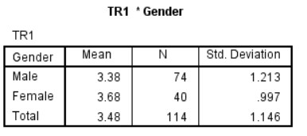

# Figure 1 TR1 * Age

TRUST1 * Age: The age group between 21 and 25 has the highest mean (3.59), while the age group over 40 has the lowest mean (2.67), with the difference happening when the usage frequency and level of trust of the two age groups diverge. Because they rarely use online platforms, according to Lazada. Age 21–25 is more important to Lazada than age >=40. completely concur with TR1 completely.

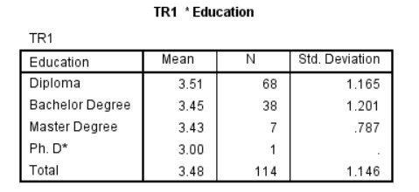

# Figure 2 TR1 * Gender

Females have the highest mean, indicating that they are more likely than men to fully agree with the protection of their personal information. According to the most recent data from the Office for National Statistics, Men's mean TR1 values are 3.38, while women's is 3.68. (ONS).

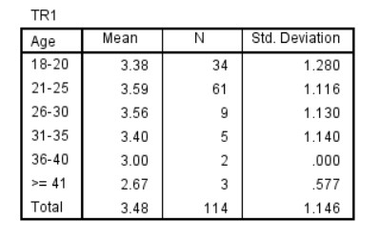

# Figure 3 TR1 * Occupation

For TRUST1 * Occupation:   Because business owners require such high levels of information security, their mean scores range from 4.00 for business owners to 3.00 for civil servants. So it stands to reason that they would agree with TR1. They agree with TR1, but only when it comes to protecting confidential data for ordinary civil servants.

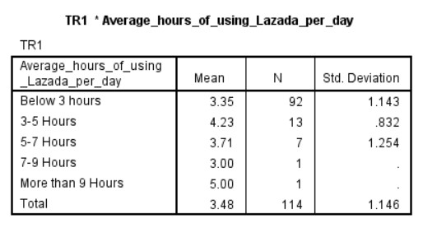

# Figure 4 TR1 * Education

For TRUST1 * Education: The highest mean on the diploma was 3.51, and the lowest mean on the Ph. D* was 3.00, although Dipoma completely agreed with TR1 child's Ph. D*; only low stats differed.

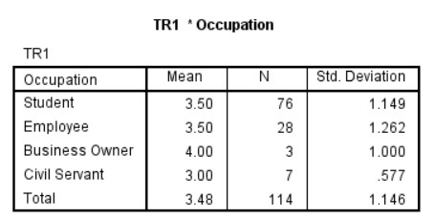

# Figure 5 TR1 * Daily Hour

For TRUST1 * Daily Hour: Because there is just one person, making an objective judgment is impossible. As a result, the case of 3-5 hours has the highest mean (mean = 4.23) and, more predictably, the case of 7-9 hours has the lowest mean (mean = 3.00). Because of the frequent use, there is correct agreement with data security in the case of 3-5 hours, and there is also agreement in the case of 7-9 hours, but only on average.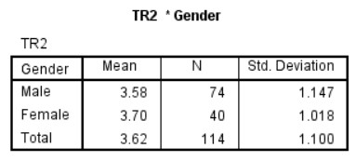

# Figure 6 TR2 * Gender

For TRUST2 * Gender, men have a mean of 3.58 points, while women have a mean of 3.70 points. This demonstrates that all women agree that Lazada protects their personal and financial information.

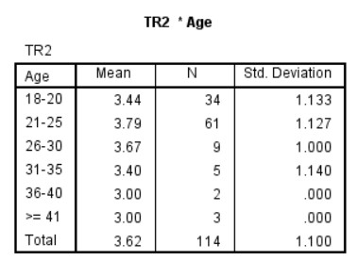

# Figure 7 TR2 * Age

For TRUST2 * Age, the age group 21 to 25 has the highest mean (3.79 points), while the age group 36 to 40 has the lowest (>=41). Because of the subjects' focus on information security and their frequent use of Lazada between the ages of 21 and 25, which explains the large difference in the mean, these individuals agree with TRUST2. completely reasonable, but there is a Mean = 3.0 between the ages of 36 and 40, and above 41, because at these ages, Lazada platform utilization is often low and security is frequently overlooked.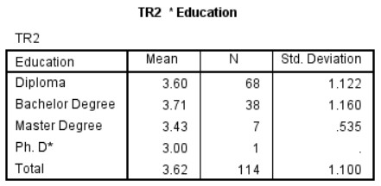

# Figure 8 TR2 * Education

For TRUST2 * Education, bachelor's degrees have the highest mean of 3.71, while doctoral degrees have the lowest mean of 3.71. This disparity stems from bachelor's degree subjects having higher shopping desires and PhD subjects having lower buying demands because they don't have the time.

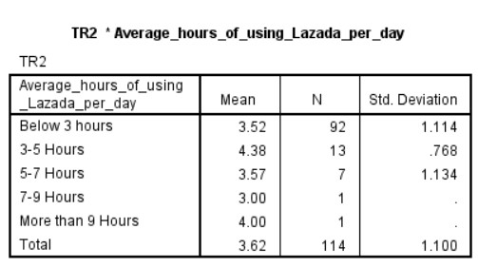

# Figure 9 TR2 * Daily Hours

For TRUST2 * Daily Hours: Lazada platform users have the highest mean, which is between 35 hours, indicating that they completely agree with TR2, and the lowest mean, which is between 7-9 hours, which is 3.00.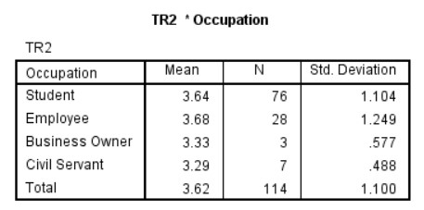

# Figure 10 TR2 * Occupation

For TRUST2 * Occupation: Employee has the highest mean Employee, 3.68, indicating that they completely agree with TR2 owing to the need to preserve personal information, prevent interruptions, and interfere with their work. lowest in government, with a mean of 3.29

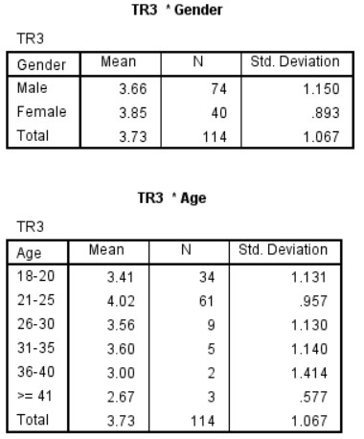

# Figure 11 TR3 * Gender and Age

For TRUST3 * Gender, men have a mean of 3.66 points, while women have the greatest mean of 3.85 points. This suggests that all women regard the Lazada platform as trustworthy.

For TRUST3 * Age: Individuals between the ages of 21 and 25 have the highest mean (4.02 points), suggesting that they believe Lazada is trustworthy, while those over 41 have the lowest mean (>=41). This age group has a low percentage of agreement due to their infrequent use of websites for online purchasing such as lazada.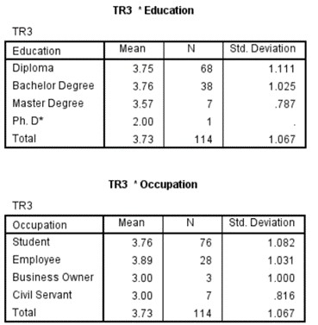

# Figure 12 TR3 * Education and Occupation

For TRUST3 * Education: The subjects with the highest mean, those with bachelor's degrees, completely agree with TR3, with a mean of 3.76. This is because the subjects in issue are students who have present and previous shopping needs. Ph. D* has the lowest Mean mean=2.00 since it is a doctorate and the student does not have sufficient time to utilize the Lazada platform, implying poor trustworthiness.

For TRUST3 * Occupation: The object with the highest mean is Employee, with a mean of 3.89, possibly showing their extensive experience with the Lazada platform and extensive shopping demands. A civil official and a company owner had the lowest agreement with a mean of 3.00 because to their workload, poor use, lack of experience, and lack of faith in Lazada.

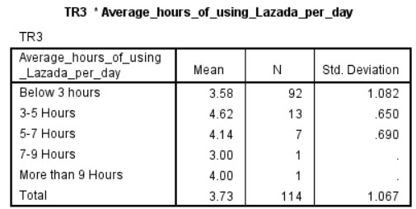

# Figure 13 TR3 * Daily Hours

TRUST3 * Occupation: Employee has the highest mean, 3.89, which is understandable considering their long experience with the Lazada site and their high level of purchase needs. A civil official and a company owner had the lowest agreement with a mean of 3.00 because to their workload, poor use, lack of experience, and lack of faith in Lazada.

**ONE SAMPLE T TEST**

|  |  |  |  |
| --- | --- | --- | --- |
|  |  | **TEST V** | **ALUE = 3** |
| **t** |  | **Sig. (2-tailed)** |
| PU1 |  | 4.494 | .000 |
| PU2 |  | 6.044 | .000 |
| PU3 |  | 7.288 | .000 |
| SVQ1 |  | 4.247 | .000 |
| SVQ2 |  | 5.399 | .000 |
| SVQ3 |  | 4.116 | .000 |
| SAT1 |  | 5.566 | .000 |
| SAT2 | 6.759 | | .000 |
| SAT3 | 6.137 | | .000 |
| TR1 | 4.200 | | .000 |
| TR2 | 4.015 | | .000 |
| TR3 | 7.100 | | .000 |

# Figure 14 One Sample T Test Table

* **PU1-- positive attitude, significant**

Respondents are extremely favorable about the importance of Lazada in their daily lives.

* **PU2-- positive attitude, significant**

Respondents are largely pleased about Lazada's utility for online shopping.

* **PU3 (Most Positive) -- positive attitude, significant**

This might be considered the favorable review with the highest index. The majority of respondents concur that Lazada makes daily shopping incredibly quick and simple.

* **SQV1-- positive attitude, significant**

Because Lazada always answers quickly when consumers have issues, respondents were unanimously favorable about the company's customer service.

* **SVQ2 (Most Positive) -- positive attitude, significant**

All respondents indicated that Lazada's customer service delivered services linked to online shopping on time and in a positive manner.

* **SVQ3-- positive attitude, significant**

Because Lazada has the expertise to address consumers' inquiries about online shopping on Lazada, respondents gave Lazada's customer service department positive feedback.

* **SAT1— positive attitude, significant**

All of the respondents indicated that Lazada met their expectations.

* **SAT2 (Most Positive) — positive attitude, significant**

Regarding their happiness with the services they obtained from Lazada, all respondents provided favorable responses.

* **SAT3— positive attitude, significant**

Respondents are really happy with the Lazada platform overall.

* **TR1 -- positive attitude, significant**

Positive and in agreement with the comments given, all of the responses. This demonstrates that Lazada offers comprehensive features to best protect users.

* **TR2-- positive attitude, significant**

The majority of survey responses focus on application trust. Everyone is very careful to protect financial information, and according to the survey's findings, Lazada is doing a good job.

* **TR3 (Most Positive) -- positive attitude, significant**

The majority of users give their opinions in favor of this question and agree with that point of view

• **CORRELATIONS**

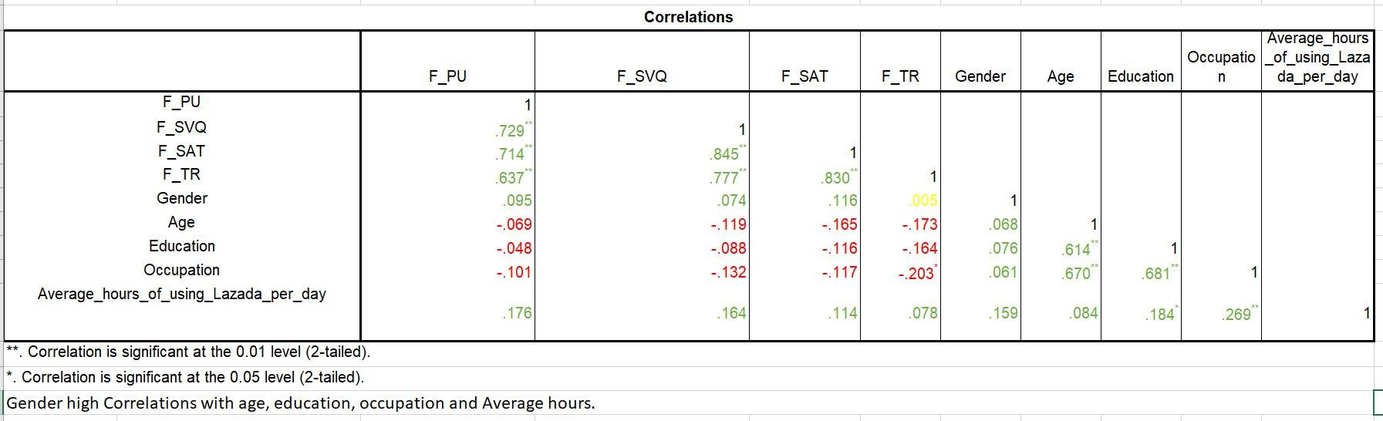

# Figure 15 Correlations Table

• Strong correlations between gender and age, education, occupation, and average hours worked.

• F_PU has a high association with F_SVQ, F_SAT, F_TR, Gender, and Average Hours, but not with Age, Education, or Occupation.

• PU, SVQ, SAT, TR have a strong correlation with each other;

• Average hours have a correlation with all factors and demographics;

• Age, Education and Occupation are not correlation with PU, SVQ, SAT and TR they have negative value but they are have correlation with each other with positive value

* **Education vs System Quality (SYSQ)**

There is a weak negative correlation between education and system quality. The less people regard the Lazada system, the better educated they are. People with a higher level of education, in my opinion, are exposed to superior systems, which results in high standards.

* **Education vs Content Quality (CTQ)**

Education and content quality have a modestly positive relationship. This is the most intriguing relationship because, in our perspective, Lazada is known for its cheap and entertaining items rather than its precious or significant items. However, the results show that this is not the case.

Higher education recipients are shown a variety of content, indicating that the Lazada reference system is extremely effective. They are unlikely to find the same information intriguing as those with lower levels of knowledge, such as high school graduates.

2 MODEL

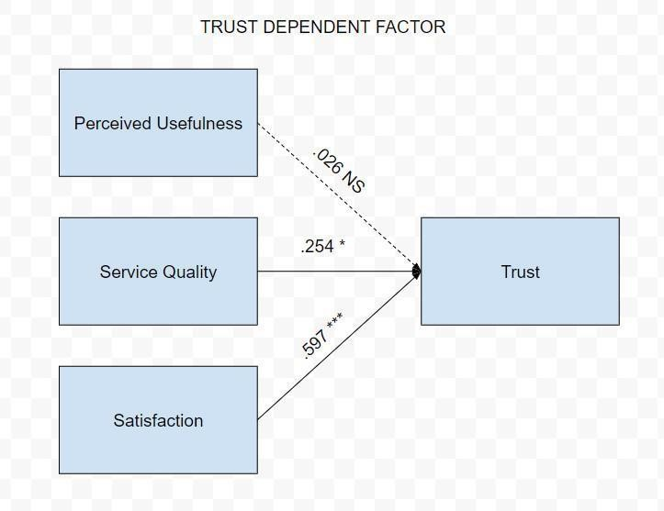

Perceived Usefulness has no significant effect on Trust (Sig. = 0.739 > 0.05), its effects are minor (Beta = 0.026 0.1), whereas the effects of Service Quality and Satisfaction on Trust are substantial (Beta (value =0.597) 0.5). After developing the final model, all of its immediate effects were investigated. The findings of the investigation confirmed that all models exhibit a positive attitude (t > 0).

The analysis results for the other two components, Service Quality and Satisfaction, demonstrate that Service Quality has a direct influence at level 0.05 (Sig. (value = 0.014) 0.05) and Satisfaction has a direct effect at level 0.01 (Sig. (value = 0.000) 0.01). The effects of these two parameters (SQ and ST) on trust are medium (Beta (value = 0.254) > 0.1) for Service Quality and large (Beta (value = 0.597) > 0.5) for Satisfaction.

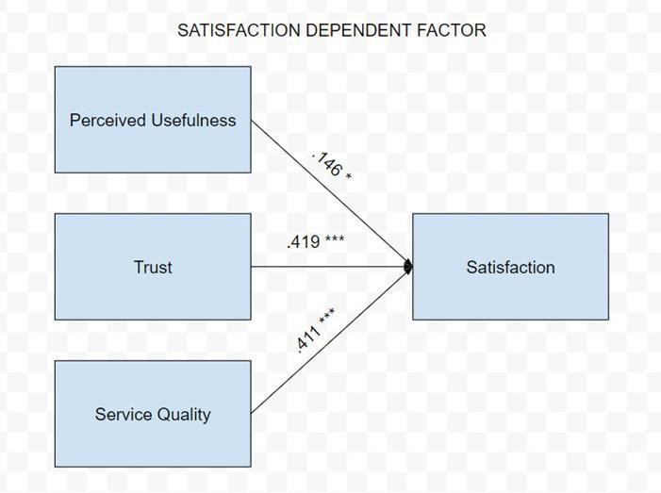

PU, SVQ, and TR are significant to SAT with p-values of 0.022, 0.0, and 0.11, respectively, and they have a substantial medium effect on Satisfaction with beta values of PU = 0.146; SVQ = 0.419; TR = 1.01; and TR = 2.11. Positive attitudes toward satisfaction are connected with t values greater than zero, while negative attitudes toward satisfaction are associated with t values less than zero.

# V. RECOMMENDED ACTIONS FOR IMPROVEMENTS AND FUTURE RESEARCH CONSIDERATIONS

## LIMITATION AND IMPROVEMENTS IN FUTURE RESEARCH

Finally, there are three constraints on this team's research project. The first is that, because the research project is primarily focused on the Lazada platform in Vietnam, the findings can only be used to produce a successful business plan for the company's headquarters. Lazada, Vietnam The second limitation is that, due to time restrictions, my team's project only received 114 responses, largely from University of Greenwich students and professors, despite the fact that we need a far higher sample size. to improve data quality in order to avoid skewed results in future studies In this study, measures such as PU and SQ show a significant dynamic separation for ST and TR. Despite TAM's excellent capacity to forecast user acceptance behavior in using Lazada for online commerce, of customers in trusting the Lazada platform to conduct online business In order to evaluate user behavior patterns and establish long-term commercial plans, my team may widen the research topic and include more factors in future studies.

# VI. CONCLUSION:

My team's first research article matched the first criteria that we had specified. Thanks to this post, my team is better able to appreciate the function of computing research in practical projects and, more crucially, the aspects that influence users through the research topic "Using this topic" thanks to this article that use Lazada for online shopping.

Mr Phyo Min Tun would want to thank him for creating favorable conditions for me to conduct this research.

# Bibliography

Das, Arindam. “Market Research Techniques for Primary and Secondary Research.” *IMS Proschool Offers Courses in Data Science, Digital Marketing, IFRS, ACCA, CFA, Business Analytics, Financial Modeling, CIMA, CFP Courses* (blog), March 26, 2019. <https://www.proschoolonline.com/blog/market-research-techniques-for-primary-and-secondary-research>.

Szerovay, Krisztina. “Secondary Research.” Medium, May 7, 2019. <https://uxknowledgebase.com/secondary-research-b19ecb6f646f>.

Roller, Margaret R. “Qualitative Data: Achieving Accuracy in the Absence of ‘Truth.’” *Research Design Review* (blog), November 21, 2016. <https://researchdesignreview.com/2016/11/21/qualitative-data-achieving-accuracy-in-the-absence-of-truth/>.

WallStreetMojo. “Quantitative Research,” October 18, 2019. <https://www.wallstreetmojo.com/quantitative-research/>.

dcnewton. “Working Remotely: The Future of Sustainability?” Office of Sustainability - Student Blog, April 3, 2020. <https://usfblogs.usfca.edu/sustainability/2020/04/03/working-remotely-the-future-of-sustainability/>.

“Tools for Remote Working - Mentimeter.” Accessed June 3, 2022. <https://www.mentimeter.com/campaigns/tools-for-remote-working>.

expii. “Scientific Method — Steps & Importance.” Accessed June 3, 2022. <https://www.expii.com/t/scientific-method-steps-importance-11026>.

Australian Environmental Education. “The Scientific Method Is a Process for Experimentation.” Accessed June 3, 2022. <https://www.australianenvironmentaleducation.com.au/education-resources/what-is-the-scientific-method/>.  
Business News Daily. “Zoom Video Conferencing 2022 Review - Businessnewsdaily.Com.” Accessed June 10, 2022. <https://www.businessnewsdaily.com/11282-zoom-video-conferencing.html>.

“Skype | Stay Connected with Free Video Calls Worldwide.” Accessed June 10, 2022. [https://www.skype.com/en//](https://www.skype.com/en/).

“Google Meet, Hangouts, and Chat: Everything You Need to Know.” Accessed June 10, 2022. <https://zapier.com/blog/google-hangouts-meet-guide/>.